Energy Assistance Program (EAP) facts

|  |  |  |
| --- | --- | --- |
| **Household Size** | **Annual Income** | **1 Month Max. Guidelines** |
| 1 | $27,047 | $2,253 |
| 2 | $35,370 | $2,947 |
| 3 | $43,692 | $3,641 |
| 4 | $52,014 | $4,334 |
| 5 | $60,336 | $5,028 |
| 6 | $68,658 | $5,721 |

* Renters & homeowners are eligible.
* Assets such as the home are not considered in determining eligibility.
* Grants range from $200 to $1,400, based on household size, income, and fuel cost.
* The average grant is about $500.
* In addition to the initial grant, additional Crisis funds are available to:
* Help pay a past due bill or get an emergency fuel delivery.
* Help homeowners get their broken furnace repaired or replaced.

EAP changes made to help during COVID-19

* The application **deadline is extended to July 1**.
* The annual **Crisis maximum is increased** **to $1,200** (up from $600).
* EAP can **help households pay a past due bill**, even without a shut-off notice.
* Income **eligibility is based on past one month** only.
* EAP still has **sufficient funds and expects more from the CARES Act**.

How to apply for EAP

* Households contact their local EAP service provider to apply for EAP.
* Households find their EAP provider:
* By calling **1-800-657-3710** & entering their zip code, or
* On this list of service providers by county or tribe at <https://mn.gov/commerce/consumers/consumer-assistance/energy-assistance/eap-provider.jsp>.
* 29 local EAP service providers including Community Action Programs, counties, tribal governments and non-profits serve all areas of the state.
* Find general EAP information at <https://mn.gov/commerce/eap.jsp> .

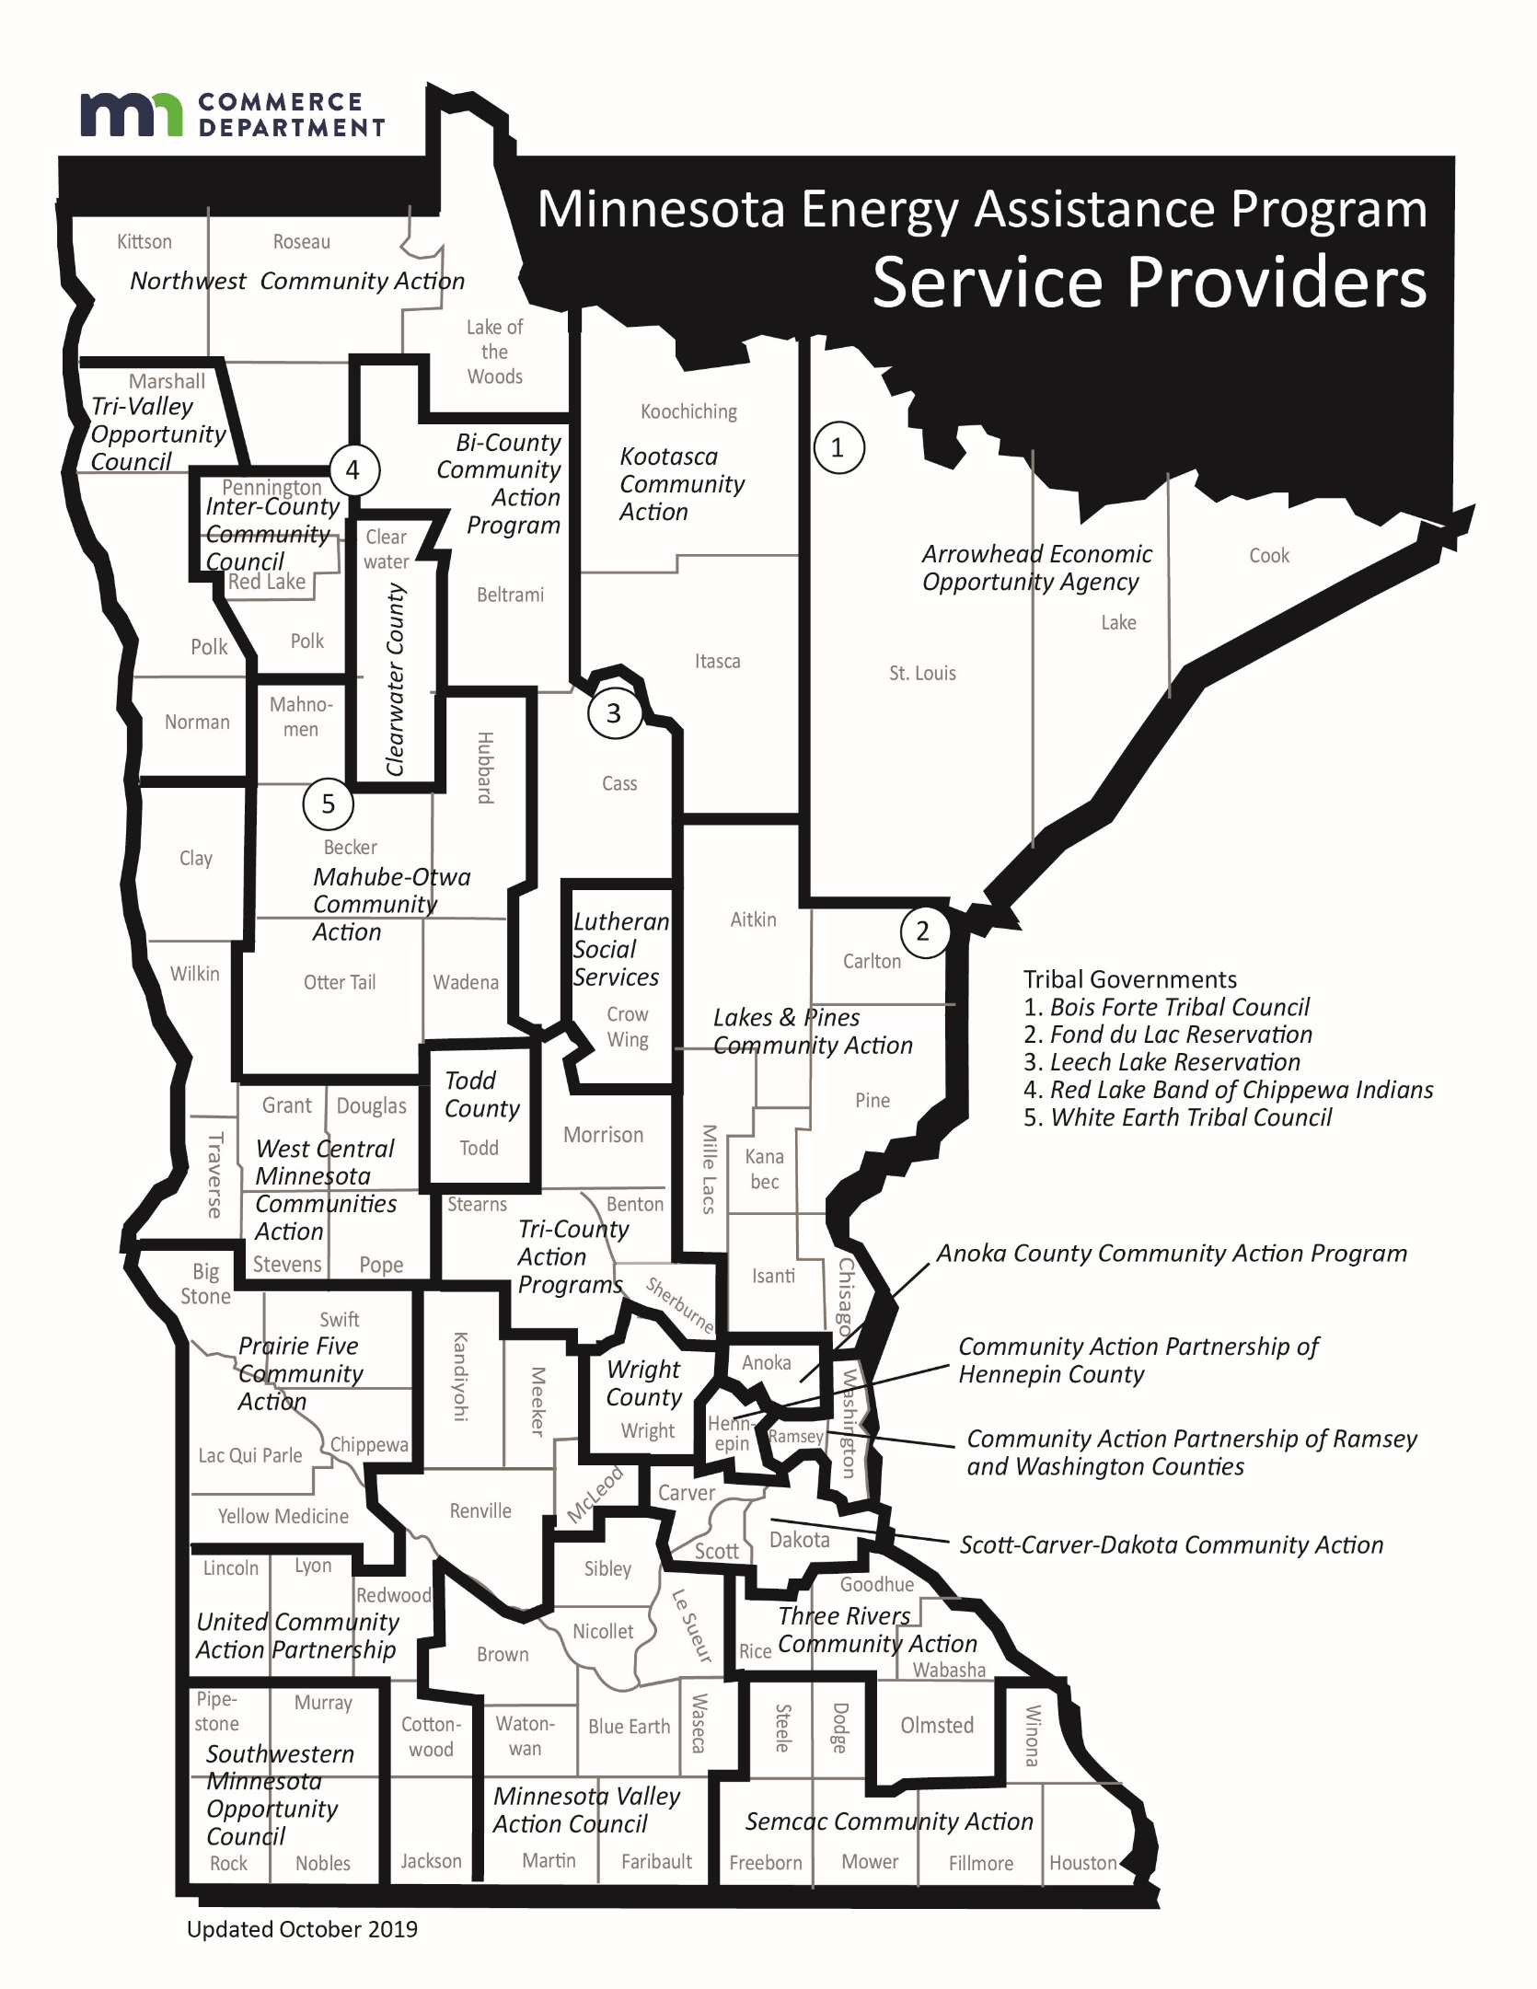

# EAP Service Provider List

|  |  |  |
| --- | --- | --- |
| **County** | **Provider** | **Contact & Location** |
| Aitkin | [Lakes and Pines Community Action Council](http://www.lakesandpines.org/) | 320-679-1800 or 1-800-832-6082  Mora, MN |
| Anoka | [Anoka County Community Action Program](http://www.accap.org/assistance-services/energy-assistance) | 763-783-4712  Blaine, MN |
| Becker | [Mahube-Otwa Community Action Partnership, Inc.](http://www.mahube.org/) | 218-847-1385 or 1-888-458-1385 Detroit Lakes, MN |
| Beltrami | [Bi-County Community Action Program](http://www.bicap.org/) | 218-751-4631 or 1-800-332-7161 Bemidji, MN |
| Benton | [Tri-County Action Programs](http://www.tricap.org/) | 320-251-1612 or 1-888-765-5597 St. Cloud, MN |
| Big Stone | [Prairie Five Community Action Council](http://www.prairiefive.org/) | 320-269-6578 Montevideo, MN |
| Blue Earth | [Minnesota Valley Action Council](http://www.mnvac.org/) | 507-345-6822 or 1-800-767-7139 ext. 2433 Mankato, MN |
| Brown | [Minnesota Valley Action Council](http://www.mnvac.org/) | 507-345-6822 or 1-800-767-7139 ext. 2433 Mankato, MN |
| Carlton | [Lakes & Pines Community Action Council](http://www.lakesandpines.org/) | 320-679-1800 or 1-800-832-6082 Mora, MN |
| Carver | [Scott-Carver-Dakota Community Action](http://www.capagency.org/) | 651-322-3500  Rosemount, MN |
| Cass | [Bi-County Community Action Program](http://www.bicap.org/) | 218-547-3438 or 1-800-332-7135 Bemidji, MN |
| Chippewa | [Prairie Five Community Action Council](http://www.prairiefive.org/) | 320-269-6578 or 1-800-292-5437 Montevideo, MN |
| Chisago | [Lakes and Pines Community Action Council](http://www.lakesandpines.org/) | 320-679-1800 or 1-800-832-6082  Mora, MN |
| Clay | [West Central Community Action](http://www.wcmca.org/) | 218-685-4486 or 1-800-492-4805 Elbow Lake, MN |
| Clearwater | [Clearwater County Dept. of Human Services](http://www.co.clearwater.mn.us/index.asp?Type=B_LIST&SEC=%7B31305E16-A370-4BF8-9ED9-563AD20F1804%7D) | 218-694-6164 or 1-800-245-6064 Bagley, MN |
| Cook | [Arrowhead Economic Opportunity Agency](http://www.aeoa.org/) | 218-749-2912 or 1-800-662-5711 Virginia, MN |
| Cottonwood | [United Community Action Partnership](https://unitedcapmn.org/) | 507-537-1416 or 1-800-658-2448 Marshall, MN |
| Crow Wing | [Lutheran Social Services of MN](http://www.lssmn.org/energyassistance/) | 218-829-5000 or 1-800-829-5902 Brainerd, MN |
| Dakota | [Scott-Carver-Dakota Community Action](http://www.capagency.org/) | 651-322-3500  Rosemount, MN |
| Dodge | [Semcac](http://www.semcac.org/) | 507-864-7515 or 1-800-944-3281 Rushford, MN |
| Douglas | [West Central MN Community Action](http://www.wcmca.org/) | 218-685-4486 or 1-800-492-4805 Elbow Lake, MN |
| Faribault | [Minnesota Valley Action Council](http://www.mnvac.org/) | 507-345-6822 or 1-800-767-7139 ext. 2433 Mankato, MN |
| Fillmore | [Semcac](http://www.semcac.org/) | 507-864-7515 or 1-800-944-3281 Rushford, MN |
| Freeborn | [Semcac](http://www.semcac.org/) | 507-864-7515 or 1-800-944-3281 Rushford, MN |
| Goodhue | [Three Rivers Community Action](http://www.threeriverscap.org/) | 507-316-0610 or 1-800-277-8418 Zumbrota, MN |
| Grant | [West Central MN Community Action](http://www.wcmca.org/) | 218-685-4486 or 1-800-492-4805 Elbow Lake, MN |
| Hennepin | [Community Action Partnership of Hennepin County](https://www.caphennepin.org/) | 952-930-3541 St. Louis Park, MN |
| Houston | [Semcac](http://www.semcac.org/) | 507-864-7515 or 1-800-944-3281 Rushford, MN |
| Hubbard | [Mahube-Otwa Community Action Partnership, Inc.](http://www.mahube.org/) | 218-732-7204 or 1-888-458-1385 Park Rapids, MN |
| Isanti | [Lakes and Pines Community Action Council](http://www.lakesandpines.org/) | 320-679-1800 or 1-800-832-6082  Mora, MN |
| Itasca | [Kootasca Community Action, Inc](http://www.kootasca.org/) | 218-999-0800 or 877-687-1163 Grand Rapids, MN |
| Jackson | [United Community Action Partnership](https://unitedcapmn.org/) | 507-537-1416 or 1-800-658-2448 Marshall, MN |
| Kanabec | [Lakes & Pines Community Action Council](http://www.lakesandpines.org/) | 320-679-1800 or 1-800-832-6082 Mora, MN |
| Kandiyohi | [United Community Action Partnership](https://unitedcapmn.org/) | 320-235-0850 or 1-800-992-1710 Willmar, MN |
| Kittson | [Northwest Community Action](http://www.northwestcap.org/) | 218-528-3258 or 1-800-568-5329 Badger, MN |
| Koochiching | [Kootasca Community Action, Inc](http://www.kootasca.org/) | 218-999-0800 or 877-687-1163 Grand Rapids and International Falls, MN |
| Lac Qui Parle | [Prairie Five Community Action Council](http://www.prairiefive.org/) | 320-269-6578 or 1-800-292-5437 Montevideo, MN |
| Lake | [Arrowhead Economic Opportunity Agency](http://www.aeoa.org/) | 218-749-2912 or 1-800-662-5711 Virginia, MN |
| Lake of the Woods | [Northwest Community Action](http://www.northwestcap.org/) | 218-528-3258 or 1-800-568-5329 Badger, MN |
| LeSueur | [Minnesota Valley Action Council](http://www.mnvac.org/) | 507-345-6822 or 1-800-767-7139 ext. 2433  Mankato, MN |
| Lincoln | [United Community Action Partnership](https://unitedcapmn.org/) | 507-537-1416 or 1-800-658-2448 Marshall, MN |
| Lyon | [United Community Action Partnership](https://unitedcapmn.org/) | 507-537-1416 or 1-800-658-2448 Marshall, MN |
| Mahnomen | [Mahube-Otwa Community Action Partnership, Inc.](http://www.mahube.org/) | 218-935-5022 or 1-888-458-1385  Mahnomen, M |
| Marshall (East) | [Northwest Community Action](http://www.northwestcap.org/) | 218-528-3258 or 1-800-568-5329 Badger, MN |
| Marshall (West) | [Tri-Valley Opportunity Council](http://www.tvoc.org/) | 218-281-9080 or 1-866-264-3729 Crookston, MN |
| Martin | [Minnesota Valley Action Council](http://www.mnvac.org/) | 507-345-6822 or 1-800-767-7139 ext. 2433  Mankato, MN |
| McLeod | [United Community Action Partnership](https://unitedcapmn.org/) | 320-235-0850 or 1-800-992-1710 Willmar, MN |
| Meeker | [United Community Action Partnership](https://unitedcapmn.org/) | 320-235-0850 or 1-800-992-1710 Willmar, MN |
| Mille Lacs | [Lakes and Pines Community Action Council](http://www.lakesandpines.org/) | 320-679-1800 or 1-800-832-6082  Mora, MN |
| Morrison | [Tri-County Action Programs](http://www.tricap.org/) | 320-251-1612 or 1-888-765-5597 St. Cloud, MN |
| Mower | [Semcac](http://www.semcac.org/) | 507-864-7515 or 1-800-944-3281 Rushford, MN |
| Murray | [Southwestern MN Opportunity Council](http://www.smoc.us/) | 507-376-4195 or 1-800-658-2444 Worthington, MN |
| Nicollet | [Minnesota Valley Action Council](http://www.mnvac.org/) | 507-345-6822 or 1-800-767-7139 ext. 2433  Mankato, MN |
| Nobles | [Southwestern MN Opportunity Council](http://www.smoc.us/) | 507-376-4195 or 1-800-658-2444 Worthington, MN |
| Norman | [Tri-Valley Opportunity Council](http://www.tvoc.org/) | 218-281-9080 or 1-866-264-3729 Crookston, MN |
| Olmsted | [Three Rivers Community Action](http://www.threeriverscap.org/) | 507-316-0610 or 1-800-277-8418 Zumbrota, MN |
| Otter Tail | [Mahube-Otwa Community Action Partnership, Inc.](http://www.mahube.org/) | 218-739-3011 or 1-888-458-1385 Fergus Falls, MN |
| Pennington | [Inter-County Community Council](http://www.intercountycc.org/) | 218-796-5144 ext. 4 or 1-888-778-4008 ext. 4   Oklee, MN |
| Pine | [Lakes & Pines Community Action Council](http://www.lakesandpines.org/) | 320-679-1800 or 1-800-832-6082 Mora, MN |
| Pipestone | [Southwestern MN Opportunity Council](http://www.smoc.us/) | 507-376-4195 or 1-800-658-2444 Worthington, MN |
| Polk (East) | [Inter-County Community Council](http://www.intercountycc.org/) | 218-796-5144 ext. 4 or 1-888-778-4008 ext. 4 Oklee, MN |
| Polk (West) | [Tri-Valley Opportunity Council](http://www.tvoc.org/) | 218-281-9080 or 1-866-264-3729 Crookston, MN |
| Pope | [West Central MN Community Action](http://www.capagency.org/) | 218-685-4486 or 1-800-492-4805   Elbow Lake, MN |
| Ramsey | [Community Action Partnership of Ramsey and Washington Counties](http://www.caprw.org/) | 651-645-6470 St. Paul, MN |
| Red Lake | [Inter-County Community Council](http://www.intercountycc.org/) | 218-796-5144 ext. 4 or 1-888-778-4008 ext. 4 Oklee, MN |
| Redwood | [United Community Action Partnership](https://unitedcapmn.org/) | 507-537-1416 or 1-800-658-2448 Marshall, MN |
| Renville | [United Community Action Partnership](https://unitedcapmn.org/) | 320-235-0850 or 1-800-992-1710  Willmar, MN |
| Rice | [Three Rivers Community Action](http://www.threeriverscap.org/) | 507-316-0610 or 1-800-277-8418 Zumbrota, MN |
| Rock | [Southwestern MN Opportunity Council](http://www.smoc.us/) | 507-376-4195 or 1-800-658-2444 Worthington, MN |
| Roseau | [Northwest Community Action](http://www.northwestcap.org/) | 218-528-3258 or 1-800-568-5329 Badger, MN |
| St. Louis (excluding City of Duluth) | [Arrowhead Economic Opportunity Agency](http://www.aeoa.org/) | 218-749-2912 or 1-800-662-5711 Virginia, MN |
| St. Louis (City of Duluth) | [Arrowhead Economic Opportunity Agency](http://www.aeoa.org/) | 218-623-3011  Duluth, MN |
| Scott | [Scott-Carver-Dakota Community Action](http://www.capagency.org/) | 651-322-3500 Rosemount, MN |
| Sherburne | [Tri-County Action Programs](http://www.tricap.org/) | 320-251-1612 or 1-888-765-5597 St. Cloud, MN |
| Sibley | [Minnesota Valley Action Council](http://www.mnvac.org/) | 507-345-6822 or 1-800-767-7139 ext. 2433  Mankato, MN |
| Stearns | [Tri-County Action Programs](http://www.tricap.org/) | 320-251-1612 or 1-888-765-5597 St. Cloud, MN |
| Steele | [Semcac](http://www.semcac.org/) | 507-864-7515 or 1-800-944-3281 Rushford, MN |
| Stevens | [West Central MN Community Action](http://www.wcmca.org/) | 218-685-4486 or 1-800-492-4805 Elbow Lake, MN |
| Swift | [Prairie Five Community Action Council](http://www.prairiefive.org/) | 320-269-6578 or 1-800-292-5437 Montevideo, MN |
| Todd | [Todd County Social Services](http://www.co.todd.mn.us/) | 320-732-4516 Long Prairie, MN |
| Traverse | [West Central MN Community Action](http://www.wcmca.org/) | 218-685-4486 or 1-800-492-4805 Elbow Lake, MN |
| Wabasha | [Three Rivers Community Action](http://www.threeriverscap.org/) | 507-316-0610 or 1-800-277-8418 Zumbrota, MN |
| Wadena | [Mahube-Otwa Community Action Partnership, Inc.](http://www.mahube.org/) | 218-632-3600 or 1-888-458-1385 Wadena, MN |
| Waseca | [Minnesota Valley Action Council](http://www.mnvac.org/) | 507-345-6822 or 1-800-767-7139 ext. 2433  Mankato, MN |
| Washington | [Community Action Partnership of Ramsey and Washington Counties](http://www.caprw.org/) | 651-645-6470 St. Paul, MN |
| Watonwan | [Minnesota Valley Action Council](http://www.mnvac.org/) | 507-345-6822 or 1-800-767-7139 ext. 2433  Mankato, MN |
| Wilkin | [West Central MN Community Action](http://www.wcmca.org/) | 218-685-4486 or 1-800-492-4805 Elbow Lake, MN |
| Winona | [Semcac](http://www.semcac.org/) | 507-864-7515 or 1-800-944-3281 Rushford, MN |
| Wright | [Wright County Community Action](http://www.wccaweb.com/) | 320-963-6500 (clients can call collect) Maple Lake, MN |
| Yellow Medicine | [Prairie Five Community Action Council](http://www.prairiefive.org/) | 320-269-6578 or 1-800-292-5437 Montevideo, MN |

### **EAP Providers by Native American Tribal Government**

|  |  |  |
| --- | --- | --- |
| **Reservation** | **Provider** | **Contact & Location** |
| Bois Forte | [Bois Forte Reservation Tribal Council](http://www.boisforte.com/) | 218-757-3261 or 1-800-221-8129 Nett Lake, MN |
| Fond du Lac | [Fond du Lac Reservation](http://www.fdlrez.com/) | 218-878-2603 or 1-800-365-1613 Cloquet, MN |
| Grand Portage | [Arrowhead Economic Opportunity Agency](http://www.aeoa.org/) | 218-749-2912 or 1-800-662-5711 Virginia, MN |
| Leech Lake | [Leech Lake Band of Ojibwe](http://www.llojibwe.com/) | 218-335-3783 or 1-866-864-8668 Cass Lake, MN |
| Lower Sioux | [United Community Action Partnership](https://unitedcapmn.org/) | 507-537-1416 or 1-800-658-2448 Marshall, MN |
| Mille Lacs | [Lakes and Pines Community Action Council](https://www.lakesandpines.org/) | 320-679-1800 or 1-800-832-6082  Mora, MN |
| Prairie Island | [Three Rivers Community Action](http://www.threeriverscap.org/) | 507-316-0610 or 1-800-277-8418 Zumbrota, MN |
| Red Lake | [Red Lake Band of Chippewa Indians](http://www.redlakenation.org/) | 218-679-1880 Red Lake, MN |
| Shakopee Mdewakanton Sioux | [Scott-Carver-Dakota Community Action](https://www.capagency.org/) | 651-322-3500 Rosemount, MN |
| Upper Sioux | [Prairie Five Community Action Council](http://www.prairiefive.org/) | 320-269-6578 or 1-800-292-5437 Montevideo, MN |
| White Earth | [White Earth Reservation](http://www.whiteearth.com/) | 218-473-2711 or 1-866-885-7656 White Earth, MN |